## Sickle cell anemia

1. **SCA** Elimination mission to eliminate it by 2047, launched in **Mission mode**
2. Autosomal **recessive** disorder (Mendelian disorder)
3. Mutation in **hemoglobin-beta** gene on **chromosome 11**
4. **Symptoms**: Tiredness, Fussiness, Swollen hands, and feet
5. India is 2nd worst country affected by SCA
6. Common among tribal populations because of **endogamy**, leads to recessive disorders
7. Sickle cell anemia protects against **malaria**. It gave an **evolutionary advantage** in malaria endemic regions (tropical regions in Africa, SA, Asia) and therefore is more prevalent there.
   1. Malaria parasite: **Plasmodium** (Protozoa)
   2. Carriers: **Anopheles** mosquitos
   3. These parasites don’t affect anopheles’ mosquitos; therefore, they carry and transfer them to humans.
   4. These parasites infect red blood cells, make them sticky and explode.
   5. This process is inhibited in sickled RBCs and therefore the affect is milder

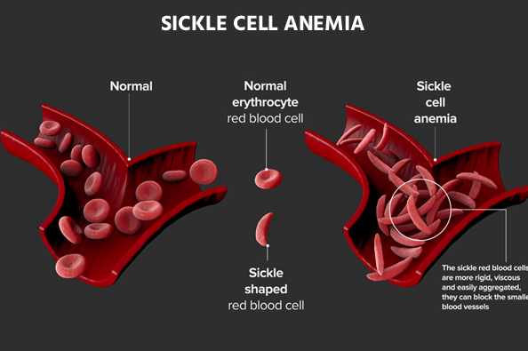

## Millets

1. Superfoods
2. Kharif Crop (27 – 32 degrees, 50-100 cm rainfall)
3. Major millets: Sorghum (Jowar), Pearl Millet (Bajra), Finger Millet (Ragi)
4. Minor millets: foxtail, little millet (Sama), proso (Variga), barnyard millet, kodo, kutki, chenna, sanwa
5. Drought resistant, less water requirement, poor soil conditions acceptable
6. Rich in nutrients: Fibre, protein, vitamins, minerals
7. Gluten free
8. Sustainable
9. Earliest reference in IVC
10. India is the largest producer, 2nd largest exporter
    1. 20% of global production, 80% of Asia’s production
11. Issues
    1. Low productivity, Low profitability
    2. Time consuming and laborious task of processing
    3. More expensive than traditional cereals
12. RJ > Karnataka > MH > MP > UP
13. Distribution
    1. **Jowar** (Sorghum): MP, MH, AP, Karnataka, TN (Central/South)
    2. **Ragi** (Finger Millet): HP, UK, Jharkhand, Sikkim, Arunachal Pradesh, Karnataka, TN (North/East)
    3. **Bajra** (Pearl Millet): RJ, GJ, Haryana, UP, MH (West)
14. Production in India: Bajra > Jowar > Ragi